Johnny Case Study 1Description
Sharp first slide:

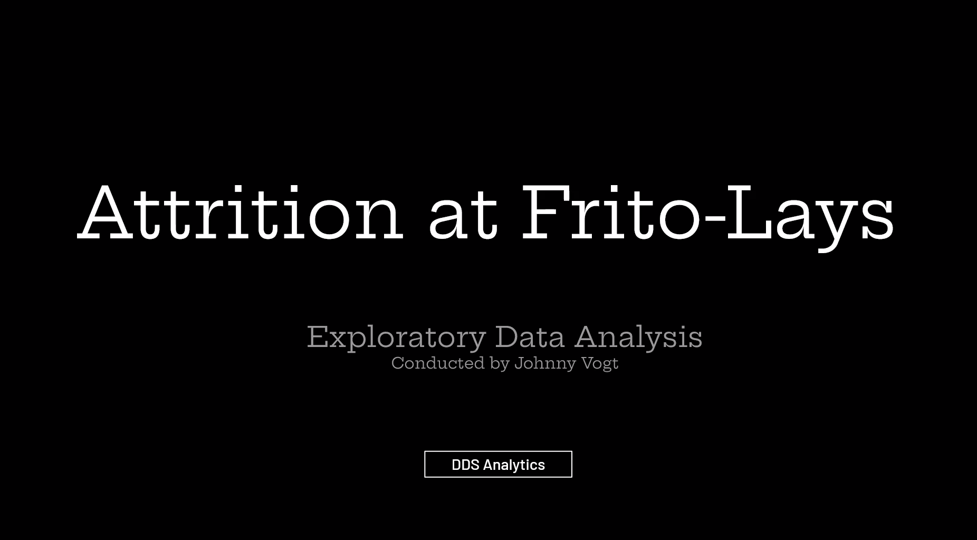
Great! Animation will help:
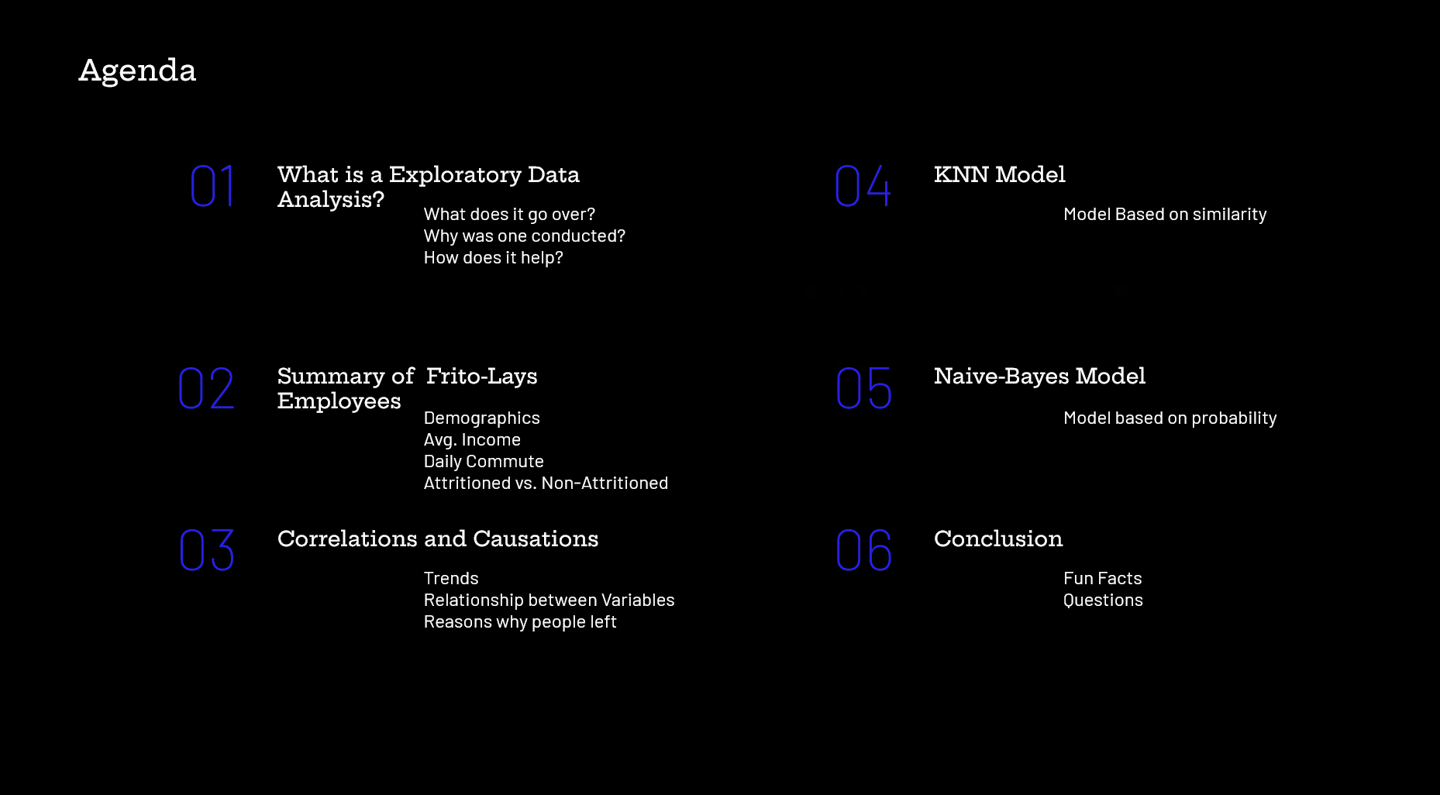
Well done! Animation will help here too.
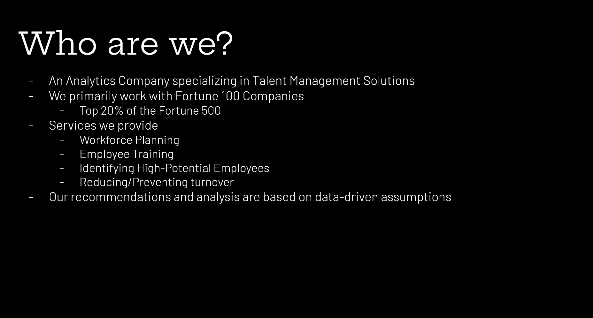
Love this… may be a place to save time if need be.
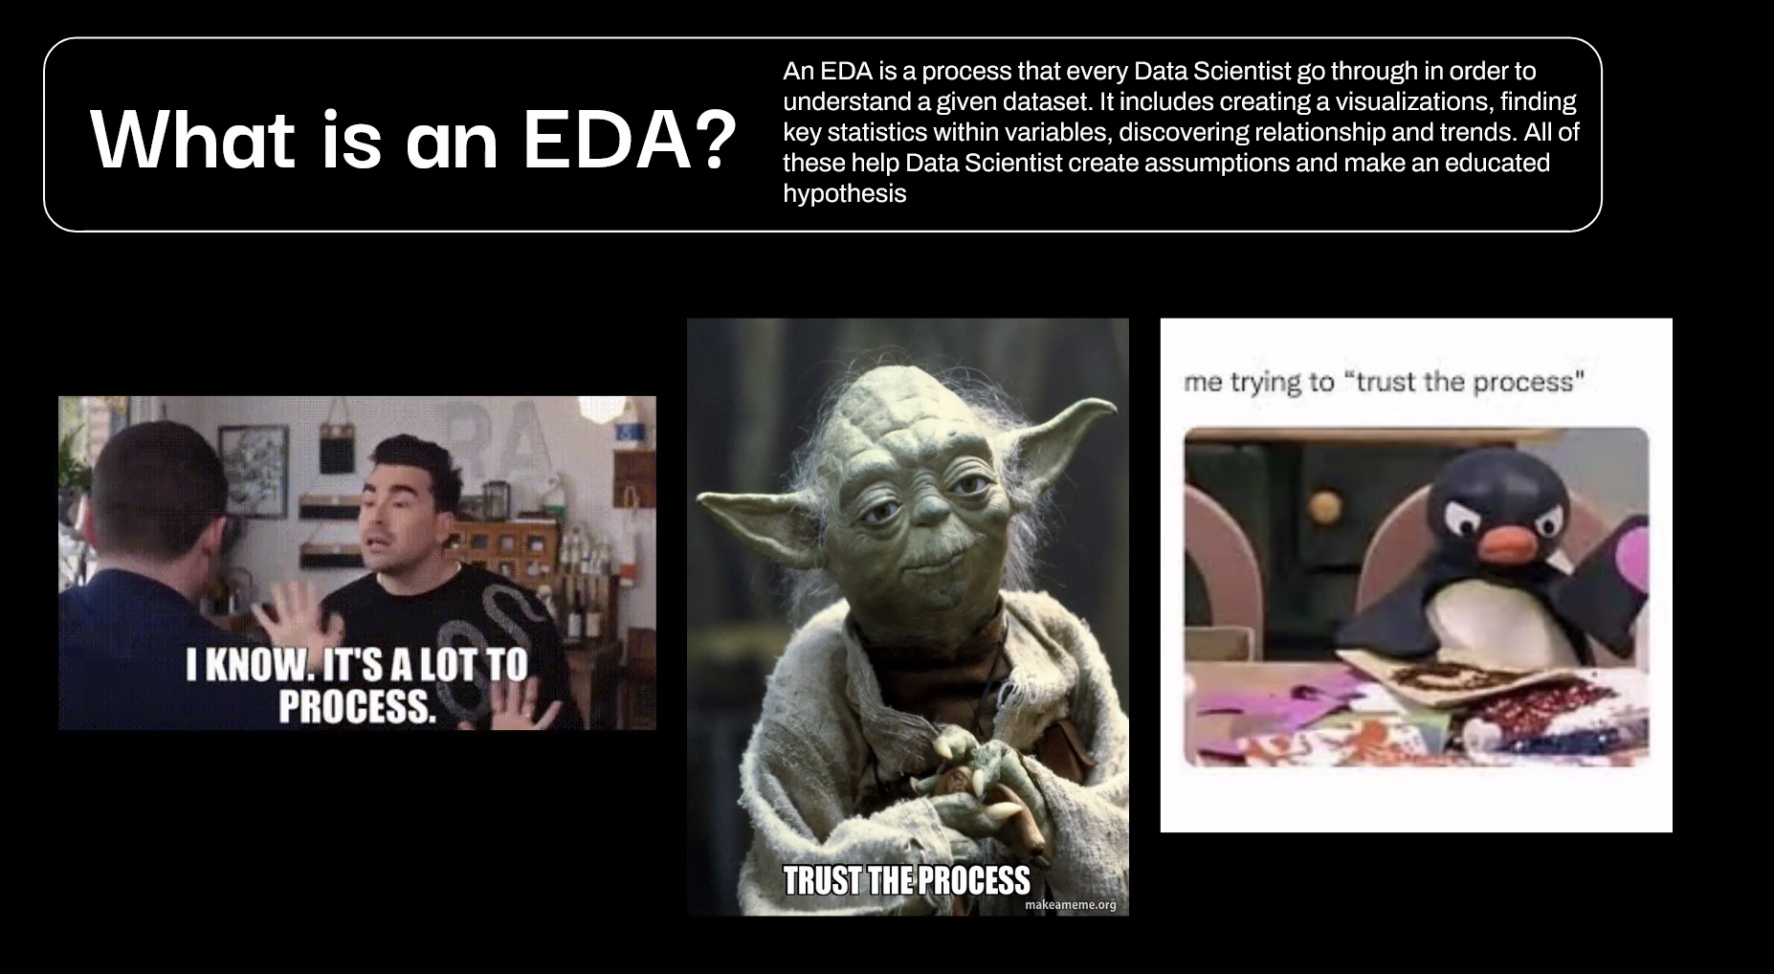
Consider making this more brief bullets
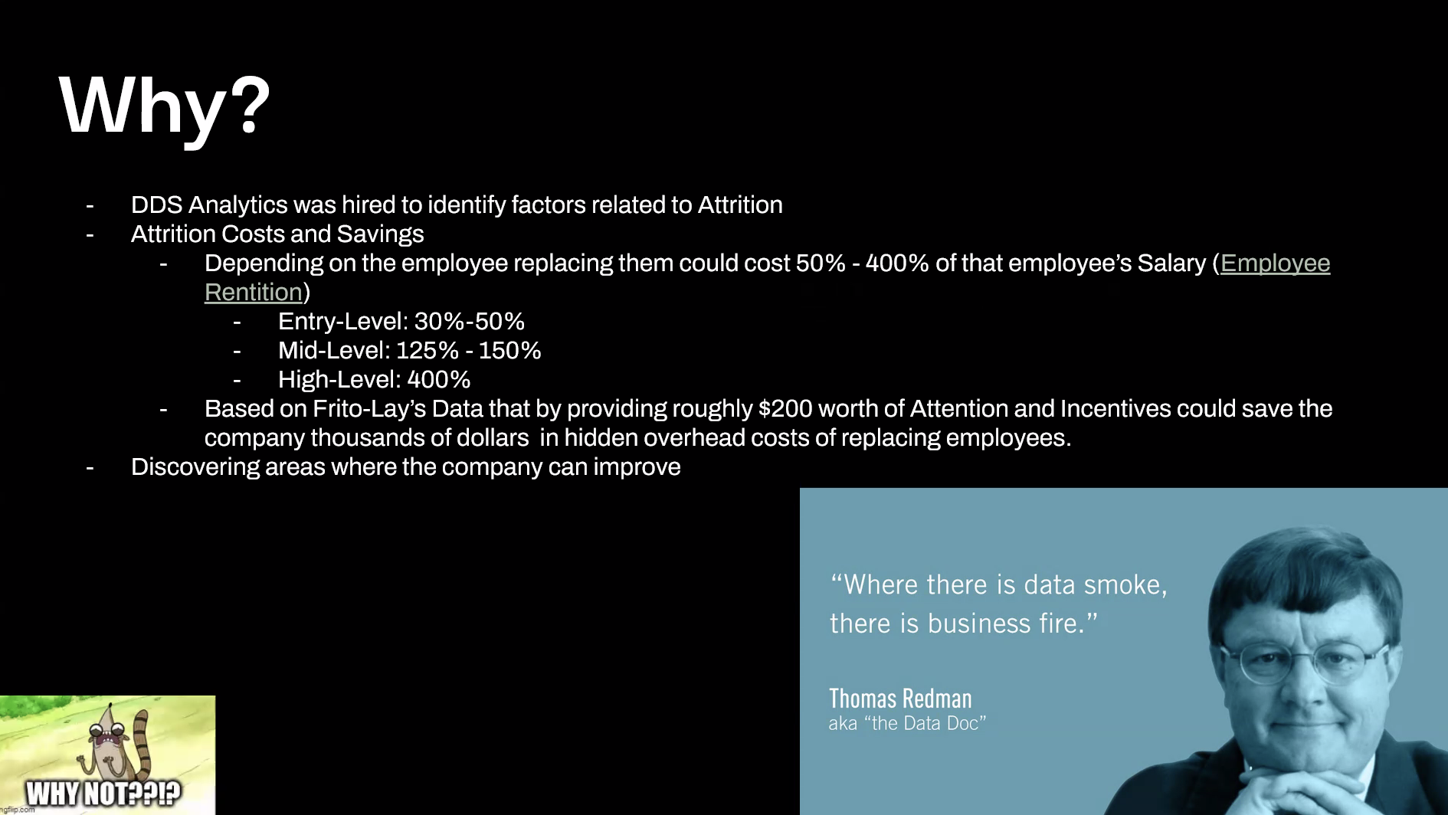
This is their salary or the cost (based on their salary) it will cost to replace them.
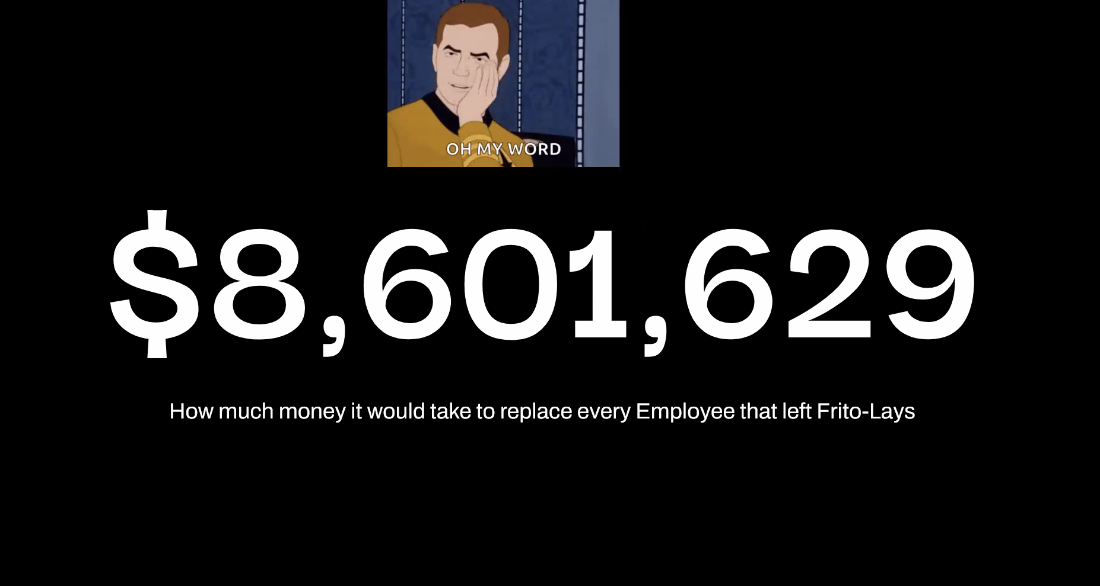
This is a lot…I would break down each of these on one slide. Great for us
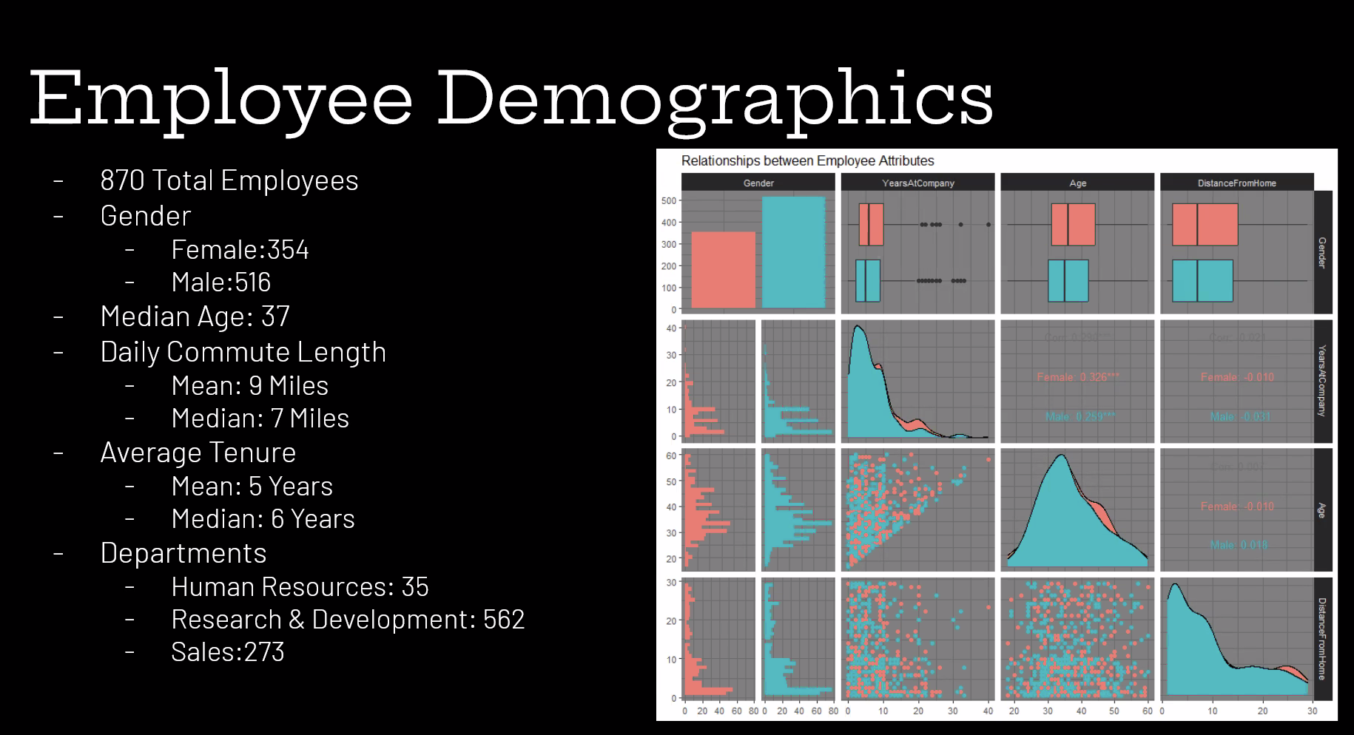
Interesting…animation will help… as well as summarized bullet points. Go through each one quickly if you deem them to be important.
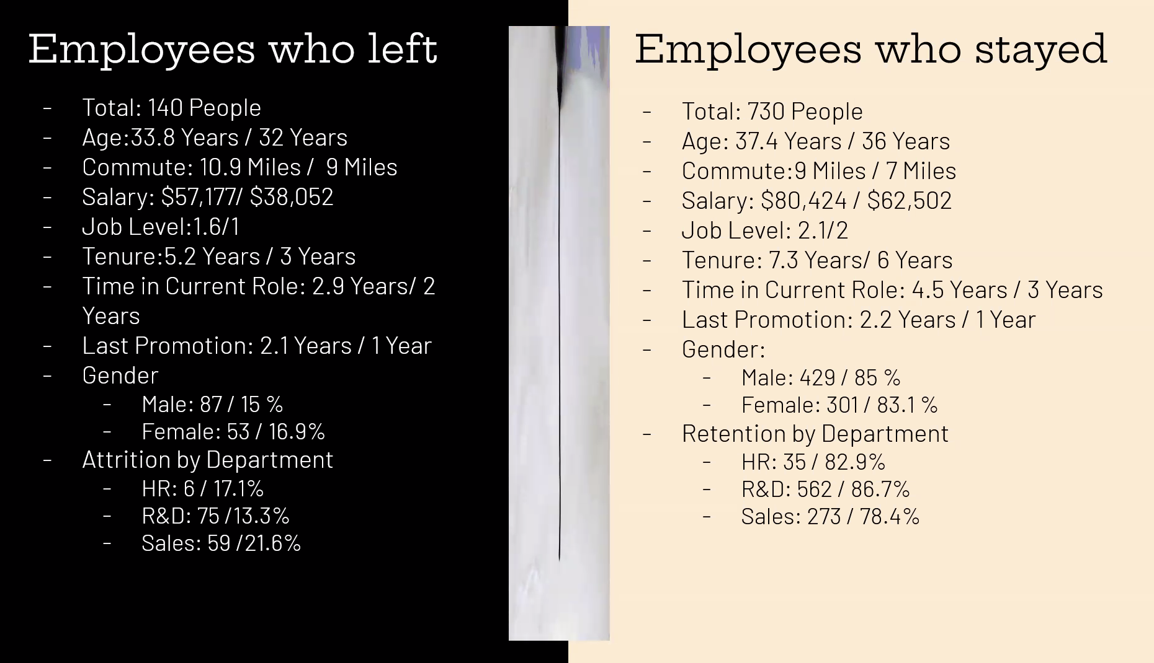
Good… needs a good description… you might show one plot at a time… then show both together.
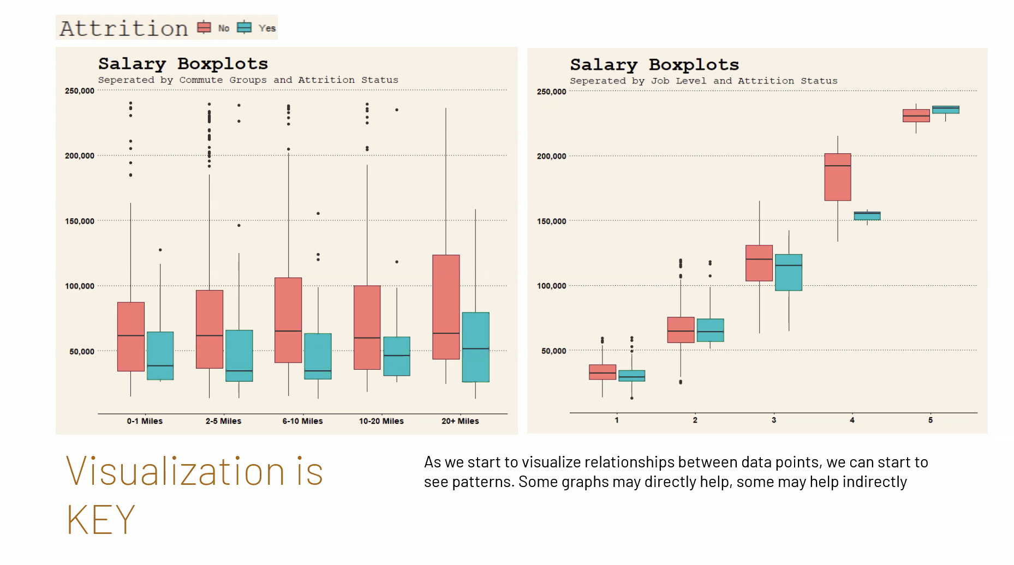

What am I looking at here?
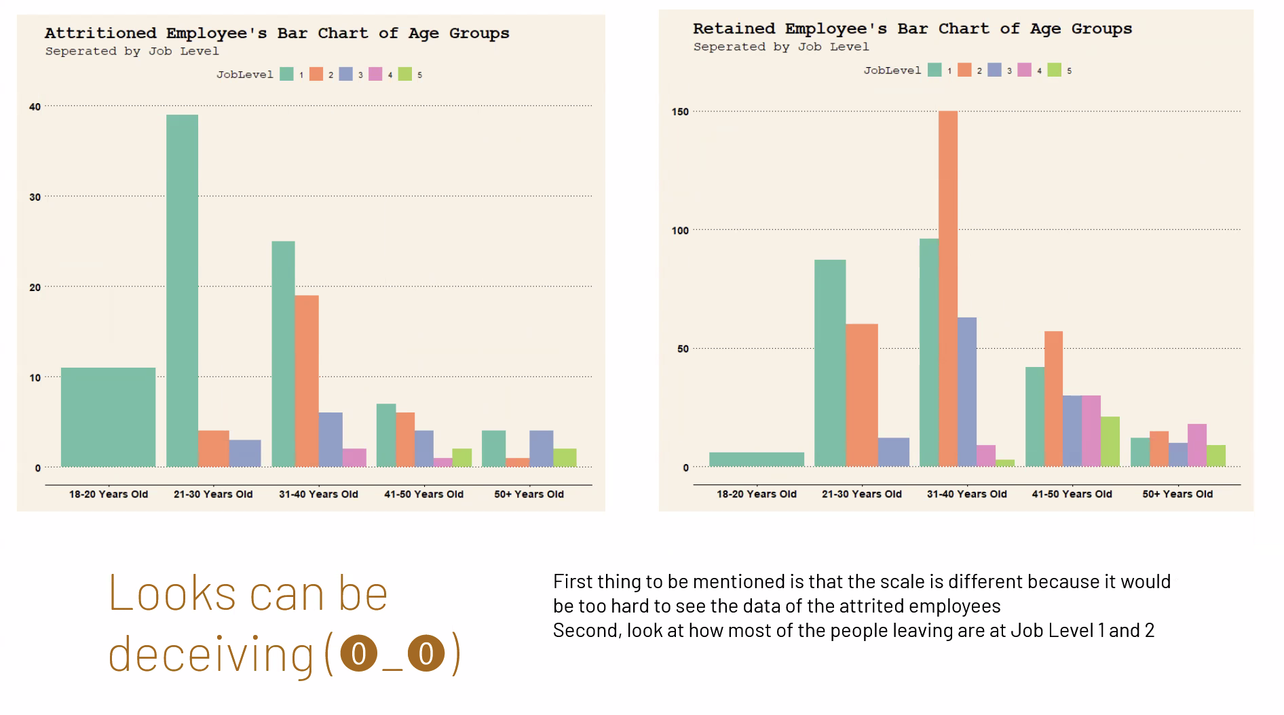
Confounding could be the reason here. Add Job Role…
Do this for Job Role on the x-axis.
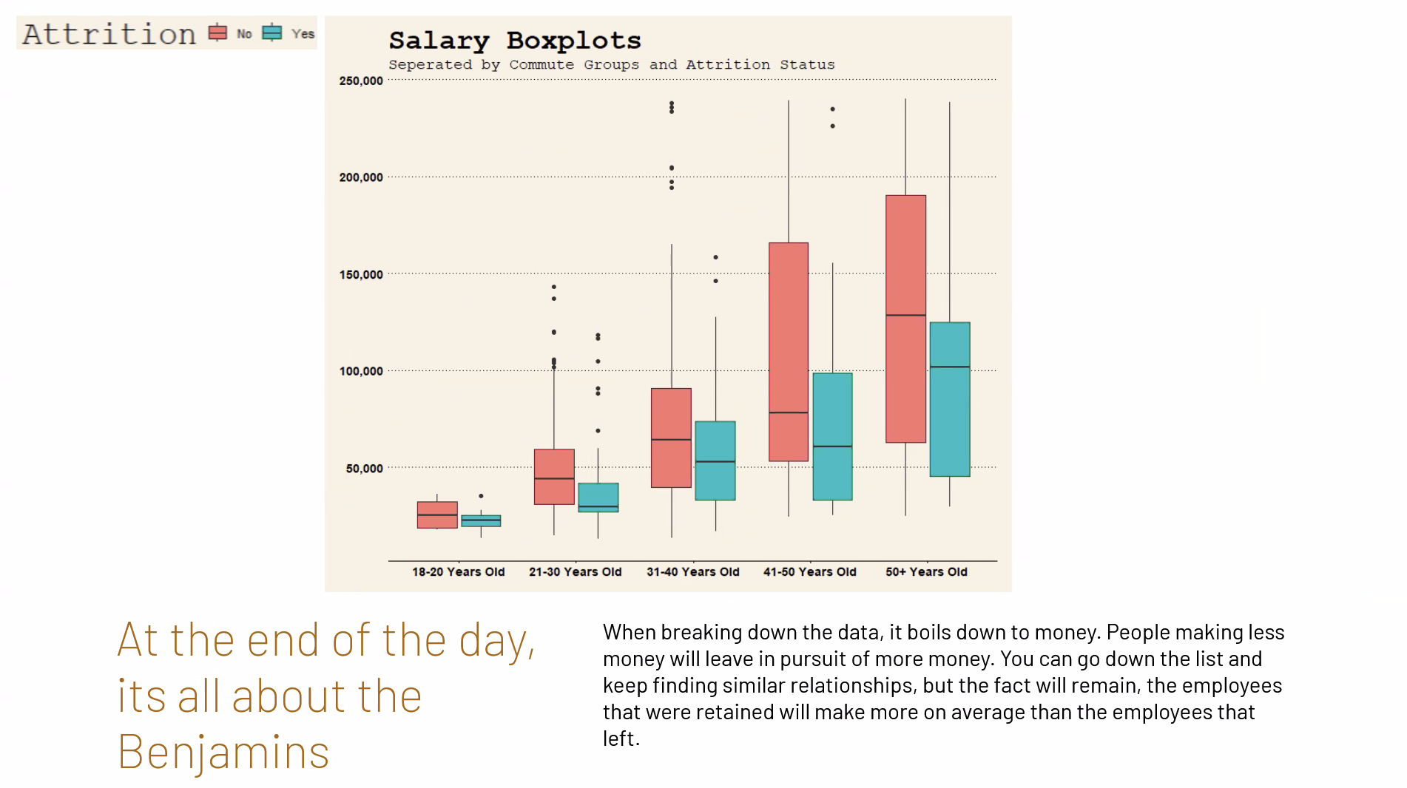
Good… adjusting the threshold should help.
Don’t need the code on the slide … play with the features and keep working with the threshold to achieve optimal sensitivity and specificity.
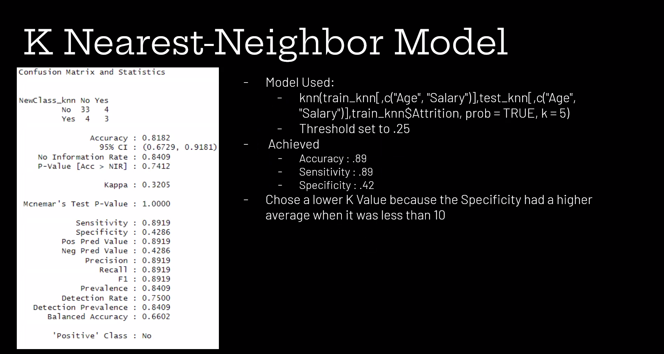
Good…same… adjust the threshold.
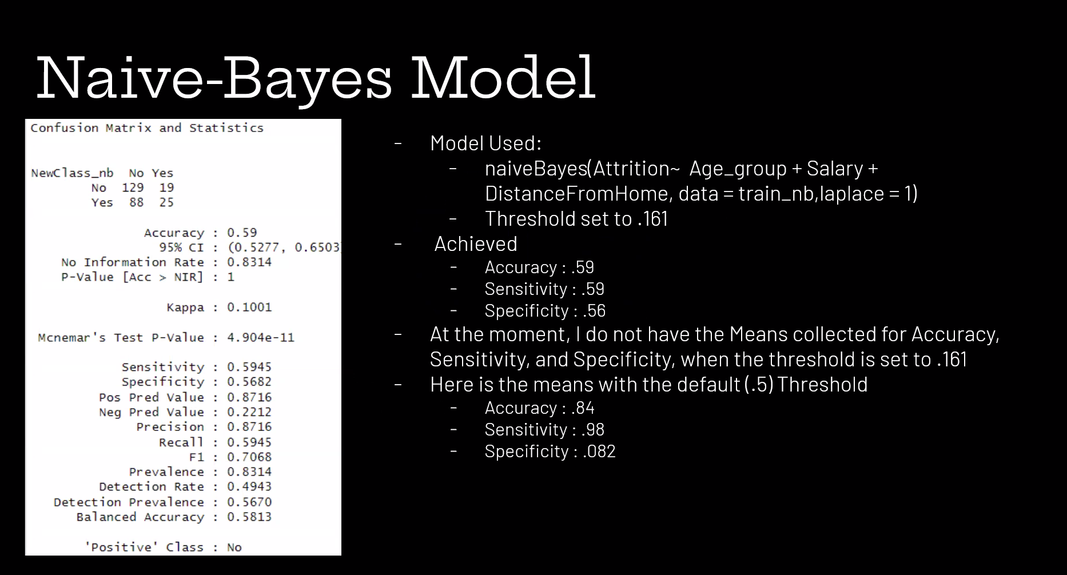
Animation will help here too.
